Research on solar simulation system for testing solar radiation measuring instruments

Zheng Ru¹ Zhang Guoyu^{1, 2} LV Wenhua³ Yan Jiajun⁴ Su Shi^{1, 2} Zhang Jian¹
(1.Changchun University of Science and Technology, Changchun 130022, China;
2.Key Laboratory of Photoelectric Measurement & Optical Information Transmission Technology of Ministry of Education, Changchun 130022, China;
3.Meteorological Observation Center, China Meteorological Administration, Beijing 10008, China;
4.Jiangsu Radio Science Research Institute Co. Ltd., Wuxi 214073, China)

Abstract: Since traditional solar simulators are mainly applied to the spacecraft and photovoltaic industry, they are not suitable for testing solar radiation measuring instruments. Therefore, a comprehensive research is carried out on solar simulators to test solar radiation measuring instruments, so as to obtain the requirements for the performance testing of these instruments. By jointly considering the requirements for national regulations of metrological verification and performance testing of pyranometer and pyrheliometer, the present paper lays emphasis on the research of design methods for improving radiation uniformity and stability of solar simulators. It also focuses on the design methods of a multidimensional detection workbench, which achieves the detection of solar radiation. On the basis of practical tests it is found that, the solar irradiation is within Φ60mm; irradiation non-uniformity is better than ±0.8%; instability is better than ±0.72%; and the rotating angle precision is better than 0.09°. Subsequently, the solar simulator is used to carry out a pyranometer sensitivity test, a pyranometer directional response test, a pyranometer tilt response test and a nonlinearity test for radiation instruments. Test results show that the solar simulator meets the testing requirements of solar radiation measuring instruments.
Keywords: solar simulation system; irradiation non-uniformity; irradiation stability; solar radiation measuring instrument

1 Introduction
Solar simulators as test and checkout equipment simulates solar radiation characteristics indoor, they have been widely applied to fields of space technology and remote sensing technology as well as solar energy industry and radiation observation industry in recent years. For example, Japanese WACOM company has developed AM0 series and AM1.5 series solar simulators respectively according to the different application demand. Each series has various solar simulators for different irradiance and different irradiation area. Such series of solar simulators are mainly applied to photovoltaic industry. Changchun University of Science and Technology as a representative university research solar simulators, combining different types of spacecraft with different types of solar sensors^{[1-5]} to design a series of solar simulators for spaceflight ground test. However, such solar simulators are not suitable for indoor test of solar radiation measuring instruments. Compared to other solar simulators, solar simulators for indoor calibration of solar radiation measuring instruments focus on high uniformity and high stability of irradiation surface. Meanwhile, solar simulators for indoor calibration of solar radiation measuring instruments shall have the function to change radiation direction. In other words, the solar simulator is a complicated optical system, its direction of optical axis cannot be changed at will. If direction of optical axis of solar radiation rays is invariable, changing included angle between optical axis of solar radiation light and the photosurface normal module of the solar radiation-measuring instrument is effective.
According to the stipulation of national regulation of metrological verification, the article focuses on the research of the key technology for solar simulators and multidimensional intelligent detection workbench with a combination of technical demand of high uniformity and high stability, as well as application demand of solar radical change in direction. Finally, the precision is verified by testing irradiation non-uniformity, instability and rotating angle. Furthermore, solar simulator test on solar radiation instruments characteristic parameter.

2 Principles and Structure of the Solar Simulation System

2.1 Solar Simulation System Composition
The solar simulation system is mainly consisted of three parts, which are solar simulator, multidimensional detection workbench and computer control system. The overall structure is as shown in Fig.1.

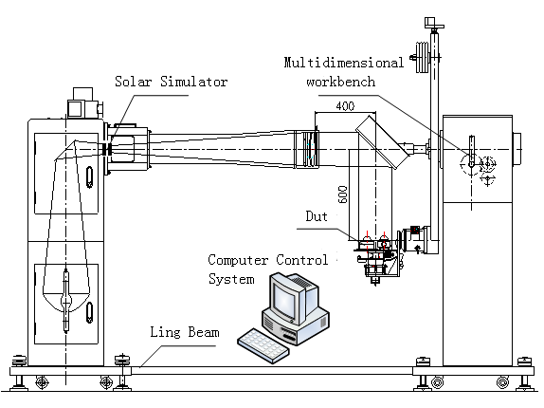
Fig.1 Overall structure diagram of the solar simulation system

The solar simulator is used for simulating solar radiation characteristics indoor and realized uniform and stable irradiation. The multidimensional detection workbench is used for installing the solar radiation measuring instrument. It cooperates with the solar simulator to generate simulation of different incident directions. The computer control system is used for controlling the multidimensional detection workbench and conducting automatic detection with high precision.

2.2 Solar Simulator Composition
The solar simulator is consisted of four parts which are optical system, mechanical system, coolant system and xenon lamp power supply. The overall layout is as shown in Fig.2.

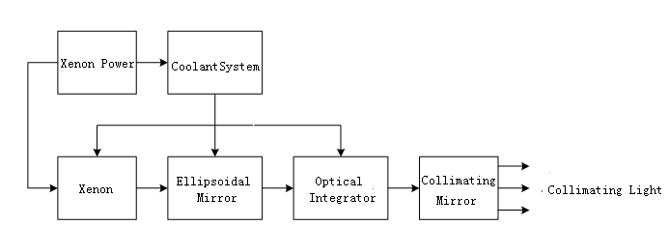
Fig.2 Block diagram for overall layout of a solar simulator

As a light source, xenon short-arc lamp is located at the first focus of ellipsoidal mirror. The light beam will converge on the second focus of the ellipsoidal mirror. Then, irradiation distribution is formed at optical integrator field lens group. Such distribution is divided symmetrically after passing through each channel of the optical integrator. After overlapping and imaging, the light beam comes out as parallel light after passing through field stop and collimating mirror. The light rays form uniform irradiation on the irradiation surface, thus, it simulates infinite solar irradiation.

2.3 Multidimensional Detection Workbench Composition
A multidimensional detection workbench for test of solar radiation measuring instrument is mainly consisted of rotating platform, elevating mechanism, pitching rotating mechanism, swing mechanism and base. It is as shown in Fig.3.

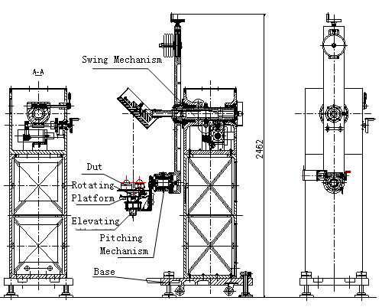
Fig.3 Overall structure diagram of multidimensional detection workbench

Four freedom adjustments of degree are ±90° pitching rotation, 360° tumbler rotation, 360° azimuth rotation and moving up. Angle rotation is realized by stepper motor driving worm gear reducer and coordinates with an photoelectric encoder. The elevating mechanism is controlled by a linear motor. Thereinto, tumbler center is equipped with a laser which is used for optical axis indication of solar radiation and optical axis indication during reflector debugging. When the multidimensional detection workbench is working, the computer control system will carry out self-inspection on zero position of each axis and restoration.

3 Key Technical Research

3.1 Key Technical Research on Solar Simulators
A solar simulator is a kind of complicated optical system, its main research purpose is how to improve irradiation non-uniformity and stability rather than imaging quality.
An optical integrator is a major component for uniform irradiation, it makes the light beam received from ellipsoidal mirror interlace and overlap. Then formed radiation turn to the collimating mirror in order to realize the uniformity of collimating light. Two supplementary lens are placed in the light path so as to improve irradiation uniformity, clarity and energy.
The optical parameter design of projection lens and field lens as well as array micro lens design are finalized during the design process of an optical integrator. In order to improve irradiation non-uniformity, caliber of projection lens should be more than light stop diameter to guarantee sufficient illumination of light stop; field lens at incident end should be consistent with projection lens at exit end; caliber of lenslet should be the same with that of lens at exit end; array micro lens of projection group should be corresponding with array micro lens of field lens. Light rays form images and overlap on the working surface. The number of channels of microarray lens is the number of division and overlapping times of radiation facula energy. Therefore, microarray lens location and number are the key points of optical integrator design. The solar simulator for test of solar radiation measuring instrument is consisted of 37 regular hexagon plano-convex lens, which the diameter is Φ8.6mm. Such lens form a polygon, its circumcircle diameter is Φ60.4 mm. It is as shown in Fig.4.

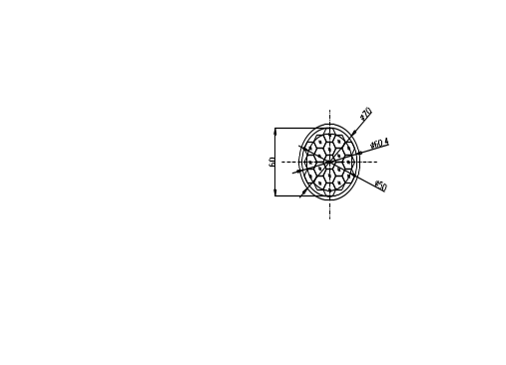

Fig.4 Structure Diagram for Optical integrator Micro Lens
The method for improving stability is mainly about using power supply to stable control of xenon lamp lighting, xenon lamp power supply with high stability is the key to improving irradiation stability. The xenon lamp power supply is mainly consisted of major loop, control loop and xenon lamp trigger circuit etc.
In consideration of reliability and controllability, power supply of xenon lamp adopts constant-current output manner, high-power and high-speed switch, as well as internal trigger type speed-sensitive switch, constant-current high-power supply control method to achiece the combination of current control and optical signal control. The circuitry is as shown in Fig.5.

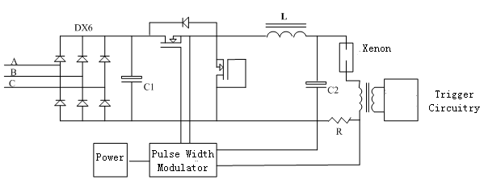

Fig.5 Xenon lamp power supply circuit diagram

3.2 Key Technical Research on Multidimensional Workbench of The Solar Simulator
When testing cosine response, azimuth response and tilt response of a solar radiation instrument, the multidimensional detection workbench cooperate with the direction of the solar simulator and different rotation, the key technology is to achieve high precision rotation.
The stepper motor driving worm gear reducer may realize rotating angle function. Stepping angle of a stepper motor, transmission ratio of a worm and resolution ratio matching are the basis for achieving the high precision rotation. Meanwhile, photoelectric encoder measures the rotating angle of a power-driven rotating platform in order to form closed-loop control. The solar simulator using 14-digit absolute photoelectric the measurement range is 0～360°.
The solar simulation system in original state is as shown in Fig 3. The photosurface of a DUT (device under test) should be vertically upward to the irradiation optical axis of a solar simulator. During a tilt response test, the photosurface of the DUT is vertical to the irradiation optical axis of the solar simulator. Then, It completes the test twice with photosurface upward or downward. At the meanwhile, rotating platform, elevating mechanism and pitching rotating mechanism are all in original state. A swing mechanism should be in the original state and rotating 180° for two tests respectively.
The directional response test includes cosine response test and orientation response test. During a cosine response test, a swing mechanism rotates by coordinating with a pitching rotating mechanism in order to guarantee the incident angle change of solar radiation rays when photosurface is in level condition. During an orientation response test, a rotating platform may realize azimuthal rotation of a DUT with assistance of a swing mechanism. Namely, a swing mechanism remains motionless when it rotates to a stipulated angle. Then, the rotating platform completes the tests of different directions and angles^{[11-15]}.

4 Performance Index Test
Performance advantages of the solar simulator system are high uniformity and high stability of irradiation surface. Compared to traditional solar simulators, it has multidimensional detection workbench which detects incidence with different radiation angles and different directions according to test requirements. Performance tests of a solar simulator mainly include irradiation uniformity test, irradiation stability test and rotating angle precision test of the detection workbench.

4.1 Performance Index Test of The Solar Simulator
When electric current of a xenon lamp is maximum, irradiation of the solar simulator is maximum irradiation output. In the current state, utilizing an irradiatometer to measure the irradiance value of multiple points within 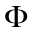60 mm irradiation facula on a multidimensional detection workbench and calculate irradiation non-uniformity. The actual measurement results are as shown in Fig.6.
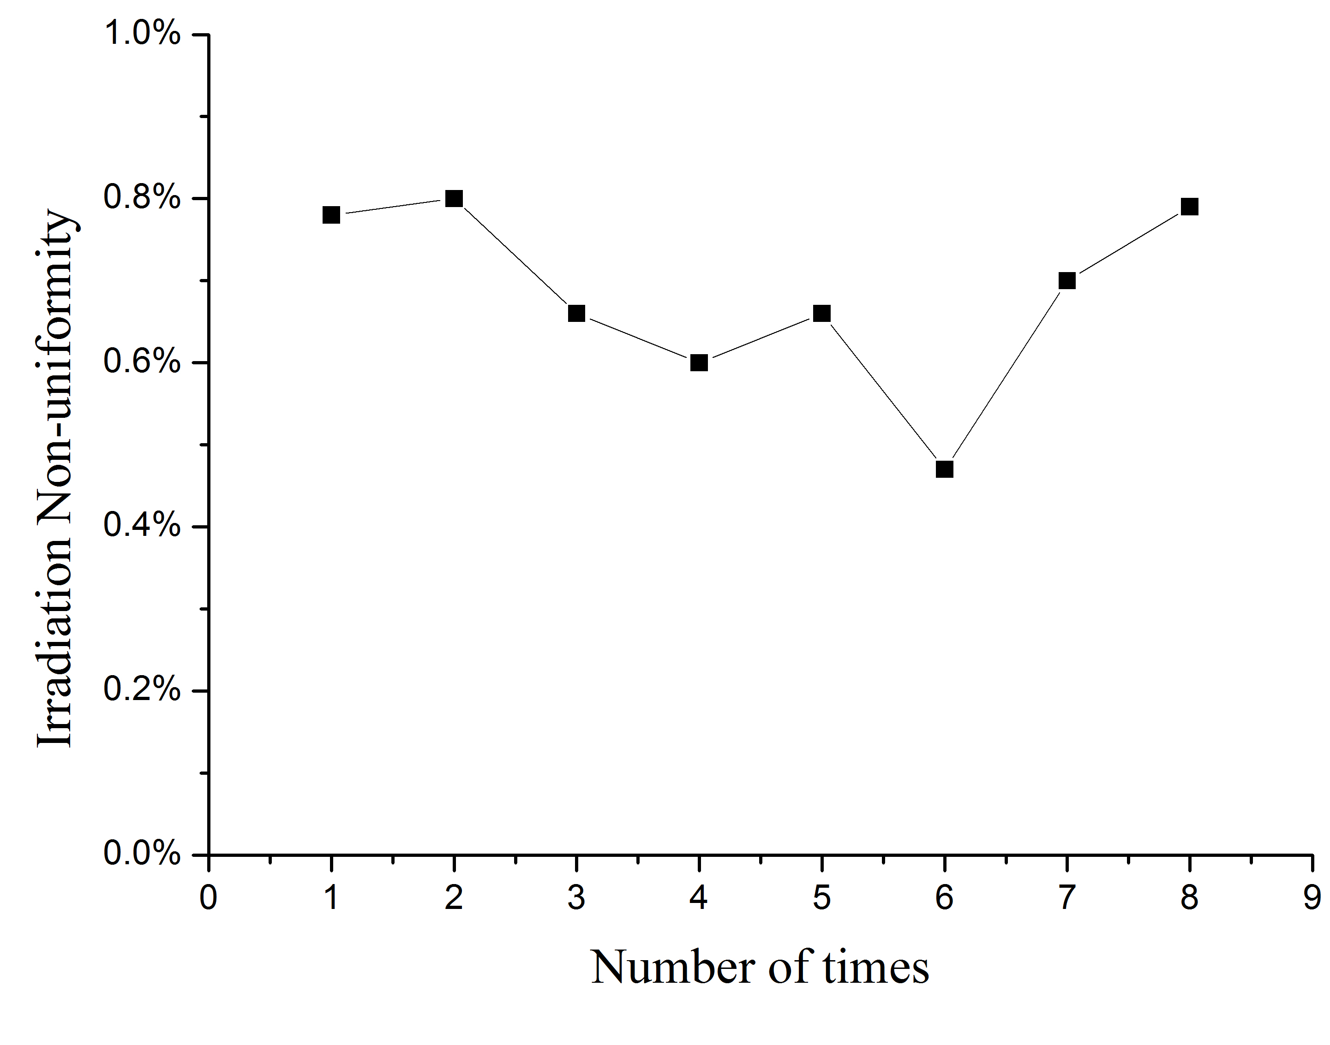

Fig.6 Irradiation uniformity test results
The test results in Fig 6, it is known that irradiation non-uniformity of the solar simulator is ±0.8%.
Testing any point within 60 mm irradiation facula on a multidimensional detection workbench to carry out continuous tests for one hour. The test is carried out every 5 minutes. The actual measurement results are as shown in Fig.7.
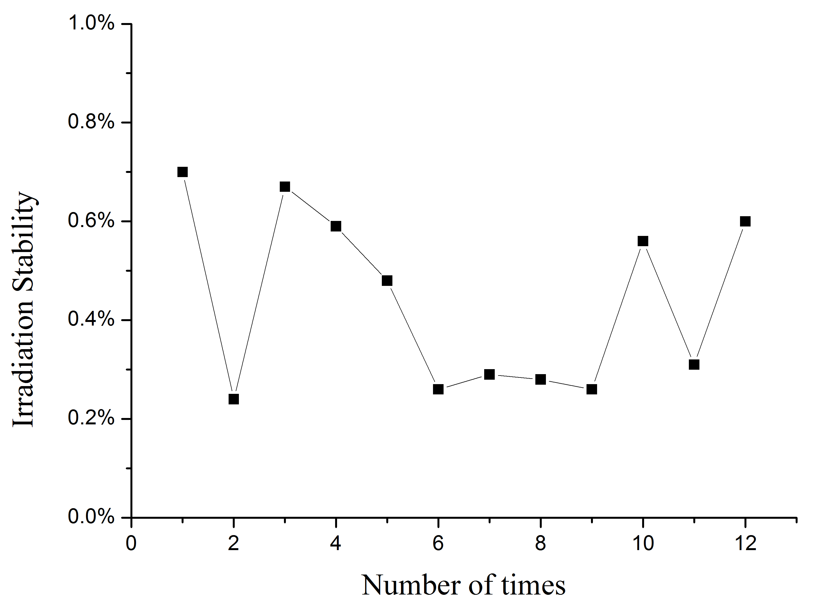

Fig.7 Irradiation stability test results
The actual measurement results in Fig 7, it is known that irradiation instability degree of the solar simulator is ±0.7%.

4.2 Performance Index Test for Multidimensional Detection Workbench
The multidimensional detection workbench can be tested by utilizing an icositetrahedron and a theodolite. At first, the icositetrahedron is put on rotors of a rotating platform, a pitching mechanism and a swing mechanism respectively. Then, It is rotated by 15° every time. After that, measure the angular difference between the cross light splitter of a theodolite and cross division line returned from icositetrahedron auto-collimation. The difference value is called rotating angle error. After actual measurement, the rotating angle error is as shown in Fig.8. The rotating angle precision is better than 0.09°.
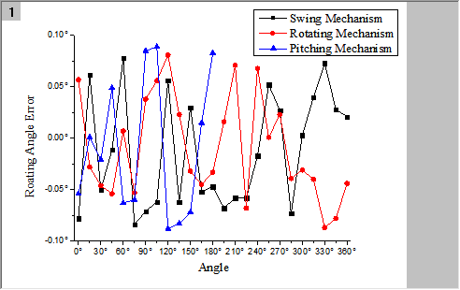

Fig.8 Rotating angle error

5 Solar Simulation System Application
The solar simulation system is mainly applied to characteristic parameter tests of solar radiation measuring instruments. Such tests include sensitivity test, directional response test and tilt response test of a pyranometer, as well as non-linearity test of radiation instruments. Test process is as shown in Fig.9.

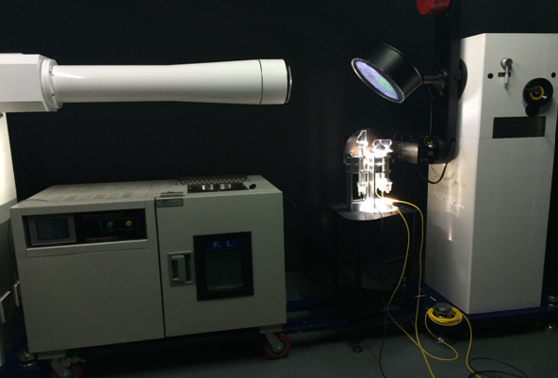

Fig.9 Test Process of Solar Radiation Measuring Instruments

5.1 Indoor and Outdoor Sensitivity Test
During indoor and outdoor tests, the standard instrument and DUT are simultaneously placed together, testing the current outdoor solar radiation or indoor irradiation of the solar simulator and recording the current irradiation output voltage. The sensitivity of standard instrument is a known magnitude. According to the output voltage and sensitivity of the standard instrument, the irradiation conditions of the sun or solar simulator can be known. Thus, the sensitivity can be calculated based on output voltage. Test data of four instruments are as shown in Table 1.

Table 1 Indoor and outdoor sensitivity test data
No. | Indoor | Outdoor | Relative Error (%)
11# | 9.422 | 9.385 | 0.4
14# | 9.554 | 9.534 | 0.2
7# | 9.694 | 9.621 | 0.8
6# | 9.328 | 9.303 | 0.3

5.2 Directional Characteristic Test of Pyranometer
Directional response refers to the error that occurred during the measurement process at any direction when incident rays vary with zenith angle change. Utilizing the solar simulator, the directional response test can be carried out. Test data are as shown in Fig.10.

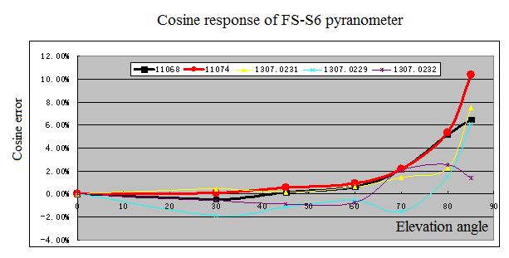

Fig.10 Directional response characteristic curve

5.3 Non-linearity Test of Radiation Instruments
Non-linearity response refers to sensitivity shift caused by difference irradiance change. Enabling output irradiance of irradiation surface to reach 100W/m², 250W/m², 500W/m², 750W/m² and 1000W/m² respectively, measure the sensitivity of a DUT. Test data are as shown in Fig.11.

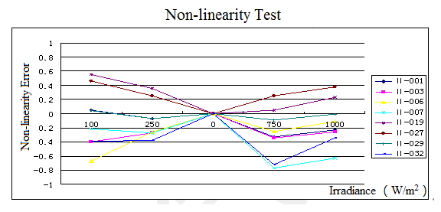

Fig.11 Non-linearity response test data

5.4 Tilt Response Test of Pyranometer
Tilt response refers to the sensitivity change caused by inclination angle change of a DUT. Test data are as shown in Fig.12.

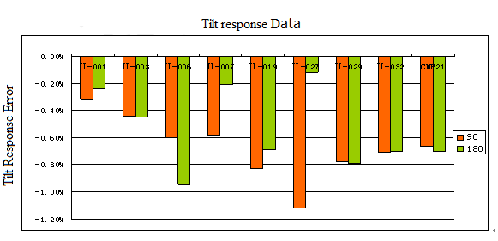

Fig.12 Tilt Response test data

It is known from Fig 10, 11 and 12 that the solar simulation system may meet the use requirements for test of solar radiation measuring instruments.

6 Conclusion
This paper focused on the research basis of the testing of solar radiation instruments. The main objective of the work was to improve the irradiation uniformity and stability of a solar simulator. The multidimensional detection workbench assisted a solar simulator in completing the tests. The paper elaborated the key technology on improving irradiation uniformity and stability respectively and carried out a comprehensive exploration of realizing multidimensional rotation. Finally, the solar simulation system was utilized to test solar radiation measuring instruments. The test results showed that the considered solar simulation system would meet the performance test requirements for solar radiation measuring instruments.

References
- People's Republic of China Standardization Management Committee. Pyranometer[R]. Beijing: Standardization Management Committee,1996: 1.
- LIU S. Design of optical system for the high-collimating solar simulator with one solar constant[J]. Acta Photonica Sinica, 2014,43(11): 67-72.
- LIU S. Opto-mechanical structure design of collimation solar simulator with high-precision[J]. Infrared and Laser Engineering, 2015, 44(4): 1229-1235.
- SU S. The research of testing system of meteorological solar radiometer[D]. Changchun: Changchun University of Science and Technology.
- KUZE N M H. Determination of tropospheric aerosol characteristics by spectral measurements of solar radiation using a compact, stand-alone spectroradiometer[J]. Applied Optics, 2010, 49(8): 1446-1458.
- ZHENG R. Research on solar radiation observation instrument and the calibration technique[D]. Changchun: Changchun University of Science and Technology,2016.
- AN G F. The optical system of solar simulator designed by the weather sonde[J]. Journal of solar energy, 2011,32(9): 1408-1412.

- ZHONG M. Optical system design and irradiation characteristics of a solar simulator[D]. Changchun: Changchun University of Science and Technology,2011.
- GAO Y. Solar simulator irradiation uniformity based on optical integrator[J]. Journal of the optical, 2012, 32(6):185-190.
- LIU C B. The optical design of the solat simulator[D]. Changchun: Changchun University of Science and Technology, 2010.
- LV W H. A lab test facility for solar radiation instruments and its application[J]. Annual report of Chinese Academy of Meteorological Sciences, 1996(1): 125-130.
- LV W H. The application of the solar simulator in the detection of radiation instruments[J]. Quarterly Journal of Applied Meteorology, 2000, 4(2): 196-200.
- LV W H. Total radiation performance evaluation[J]. Meteorological Hydrological Sea Instrument, 2001, 12(2): 196-201.
- LV W H. Research on performance testing of pyrheliometers[J]. Chinese Journal of Scientific Instrument, 2013, 34(12):19-24.
- WANG C. Analysis for Nonlinear Error Measurement Method of Pyranometer[J]. Journal of Electronic Measurement and Instrument, 6(27): 555-559.

AuthorBiographies
Photo
Zheng Ru received master's degree from Changchun University of Science and Technology in 2012．Now she is a PhD candidate in CUST．His main research interest is spacecraft ground calibration and measurement.
E-mail：zhengrupp@126.com

Zhang Guoyu received PhD from Changchun University of Science and Technology (CUST) in 2005. He is currently a professor and PhD supervisor in CUST. His main research interests include space science and technology, photoelectric instrument and measurement technique, etc.
E-mail：zh_guoyu@163.com

